Instructions – Business Cards
The business cards design is a Variable Data Print (VDP) InDesign document utilizing Data Merge .
- Modify or add to the data set as needed by opening the file Employees.csv in Excel.
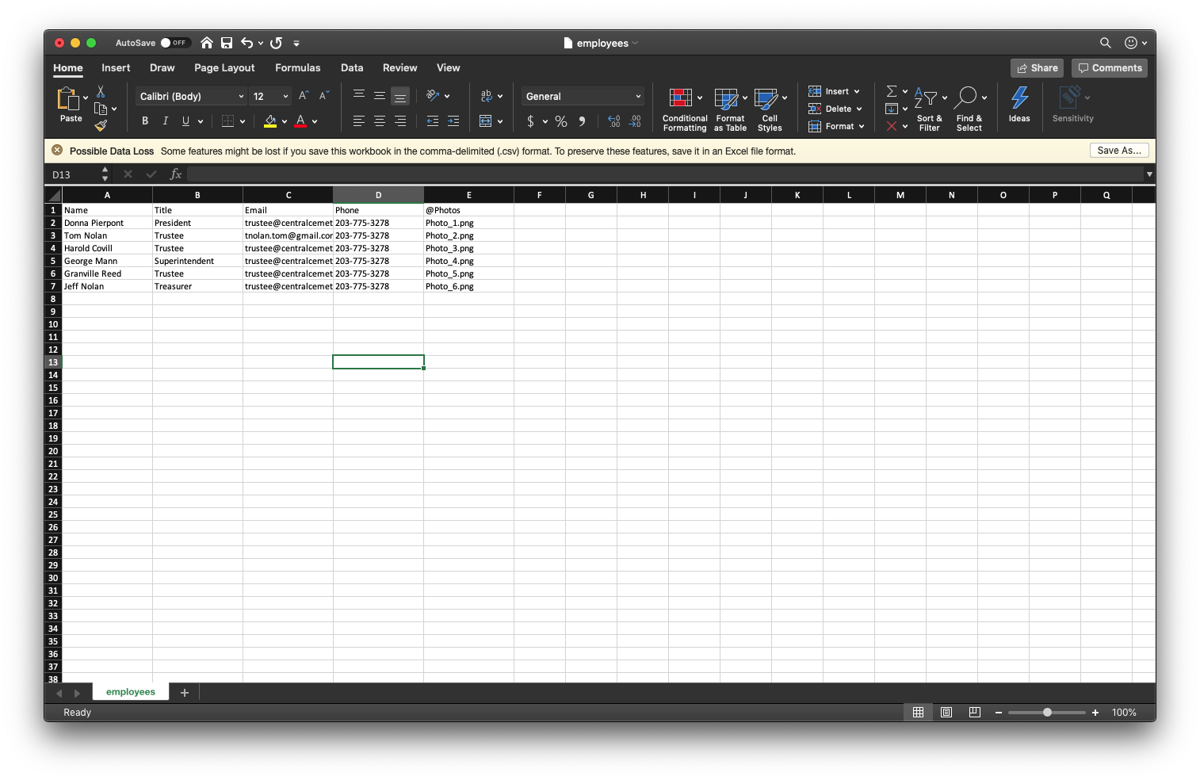
- Open BizCard.indd or BizCard.idml in InDesign.
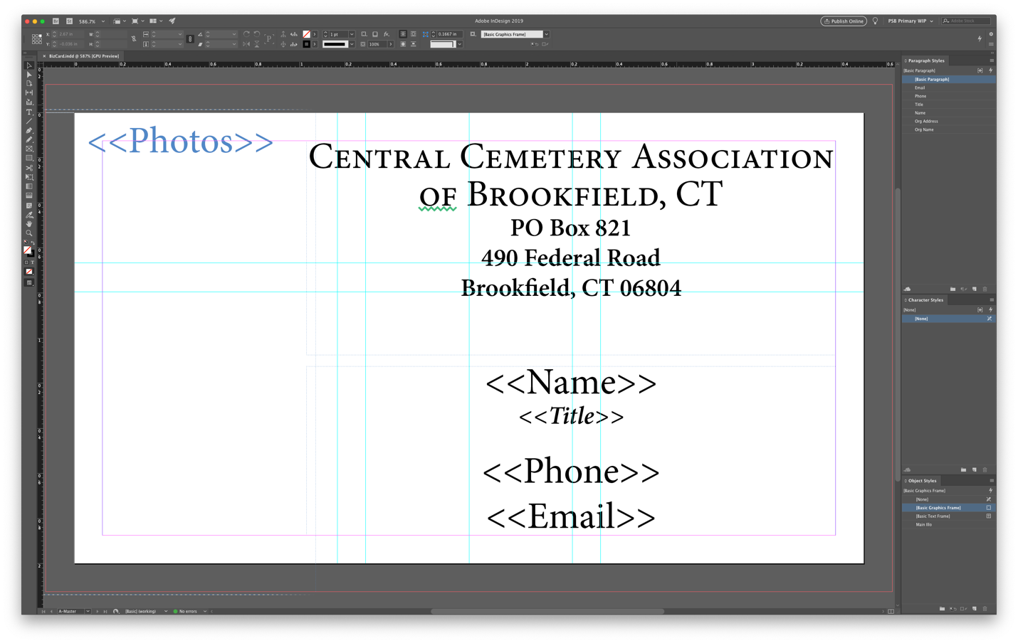
- From the Window menu in InDesign select Utilities > Data Merge to open the Data Merge panel. It should already be connected to the data source and populated with the fields (see image below).
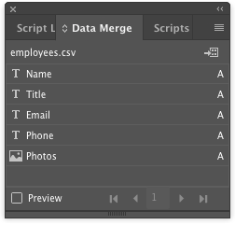
If the document has lost contact with the data source—which can happen when transferring InDesign documents between systems—choose Select Data Source from the panel menu and navigate to the Employees.csv file in the same folder as the INDD and IDML files.
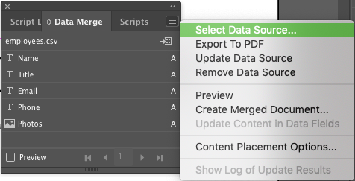
- If you don’t need to Select Data Source, you will need Update Data Source, especially if you’ve edited Employees.csv in Excel. To do that, select Update Data Source from the Data Merge panel.
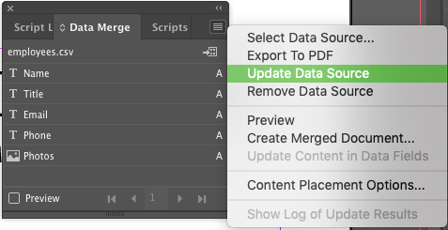
- Preview how the data will import by selecting the Preview control on the bottom of the Data Merge panel.
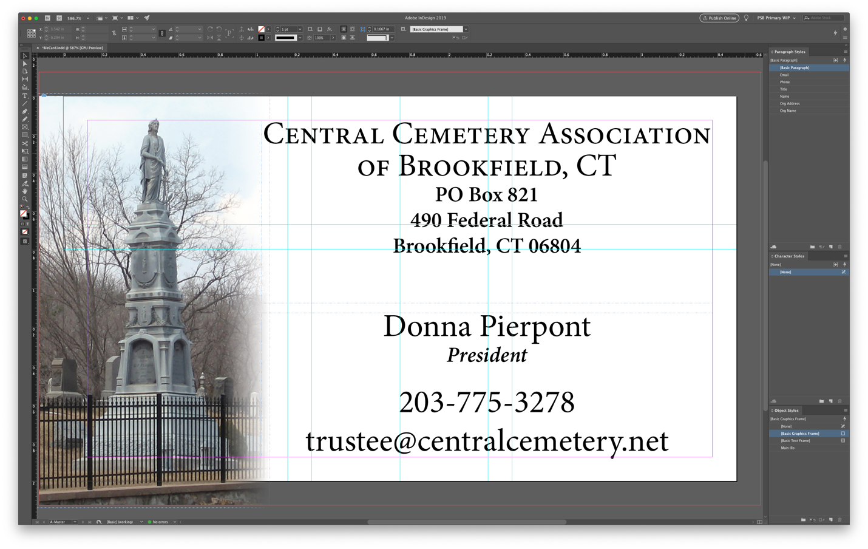
Continue previewing by using the arrows on the bottom of the Data Merge panel to move between records.
- When ready to convert the business cards into PDF, Choose Export to PDF from the Data Merge panel menu.
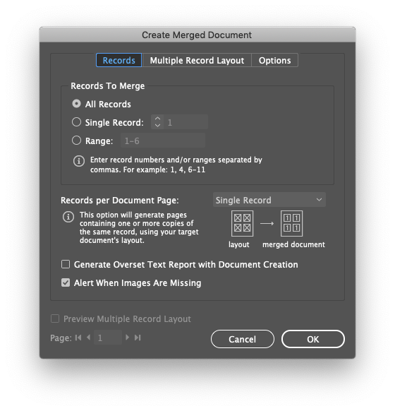
- When the Create Merged Document dialog appears, set the controls to match the below screenshot before clicking OK. When you’ve finished, you’ll have one PDF containing all the business cards.

