Board of Trustees  Donna Pierpont  President, Secretary  (845) 406-8978  Jeffrey G. Nolan  Treasurer, Sexton  (203) 466-6313  George Mann  Superintendent  (860) 354-1645  Harold Covill  (203) 868-2944  Thomas R. Nolan  (203) 775-2762  Graville Reed  (203) 788-4959 | September 26, 2019  Hon. Dianne Yamin  Danbury Probate Court  155 Deer Hill Avenue  Danbury, Connecticut 06810  (203) 797-4521  Dear Dianne:  Thank you for your time on  - Xxxx A large and;  - x. That same mostly-volunteer group is.  xxx  Your honor, thank you.  Sincerely,  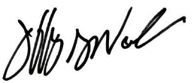  Trustee

